Lieutenant W A Taylor
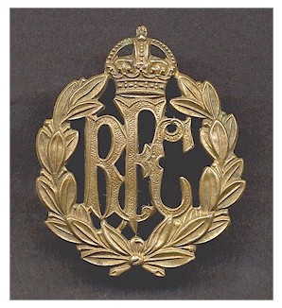
Royal Flying Corps
Royal Flying Corps

Rank: Lieutenant
Date of Death: 10/08/1917
Regiment/Service: Royal Flying Corps, 8th
Sqdn. and General List
Grave Reference: A. 447.
Cemetery: NEW KILPATRICK (OR HILLFOOT) CEMETERY

