Captain Charles Mortimer Austin Gunn
11th Battalion Cameronians (Scottish Rifles)

Rank: Captain
Date of Death: 20/05/1917
Age: 21
Regiment/Service: Cameronians (Scottish Rifles), "A" Coy. 5th Bn.
Panel Reference: Bay 6.
Memorial: ARRAS MEMORIAL

Additional Information:
Son of Richard and Thomasina Gunn, of 49, Camarvon St., Glasgow. Commissioned to 11th Bn. in Nov., 1914. Wounded at Mametz, Oct.,.

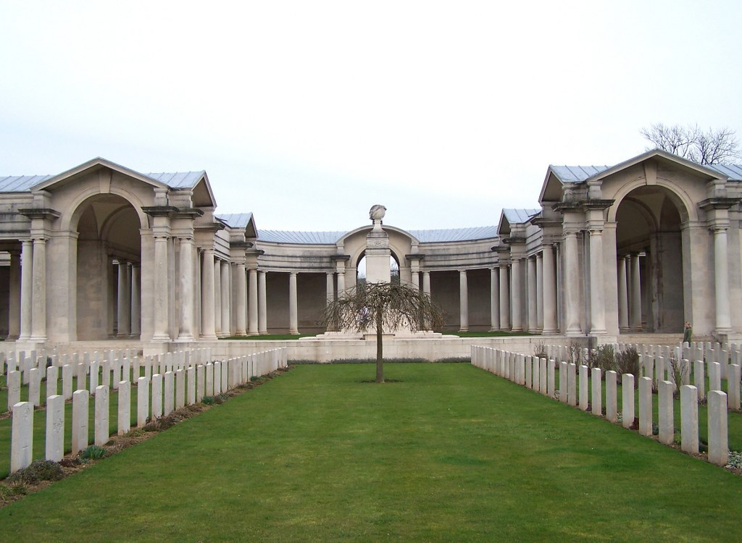
Arras Memorial, France

Country: France
Locality: Pas de Calais
Identified Casualties: 34766

Location Information
The Arras Memorial is in the Faubourg-d'Amiens Cemetery, which is in the Boulevard du General de Gaulle in the western part of the town of Arras. The cemetery is near the Citadel, approximately 2 kms due west of the railway station.
The GPS coordinates for the cemetery are 50.28670, 2.76057

Visiting Information
Wheelchair access to the memorial is possible via an alternative entrance at the rear of Faubourg-d'Amiens Cemetery.

Historical Information
The French handed over Arras to Commonwealth forces in the spring of 1916 and the system of tunnels upon which the town is built were used and developed in preparation for the major offensive planned for April 1917.
The Commonwealth section of the FAUBOURG D'AMIENS CEMETERY was begun in March 1916, behind the French military cemetery established earlier. It continued to be used by field ambulances and fighting units until November 1918. The cemetery was enlarged after the Armistice when graves were brought in from the battlefields and from two smaller cemeteries in the vicinity.
The cemetery contains over 2,650 Commonwealth burials of the First World War, 10 of which are unidentified. The graves in the French military cemetery were removed after the war to other burial grounds and the land they had occupied was used for the construction of the Arras Memorial and Arras Flying Services Memorial.
The adjacent ARRAS MEMORIAL commemorates almost 35,000 servicemen from the United Kingdom, South Africa and New Zealand who died in the Arras sector between the spring of 1916 and 7 August 1918, the eve of the Advance to Victory, and have no known grave. The most conspicuous events of this period were the Arras offensive of April-May 1917, and the German attack in the spring of 1918. Canadian and Australian servicemen killed in these operations are commemorated by memorials at Vimy and Villers-Bretonneux. A separate memorial remembers those killed in the Battle of Cambrai in 1917.
The adjacent ARRAS FLYING SERVICES MEMORIAL commemorates almost 1,000 airmen of the Royal Naval Air Service, the Royal Flying Corps, and the Royal Air Force, either by attachment from other arms of the forces of the Commonwealth or by original enlistment, who were killed on the whole Western Front and who have no known grave.
During the Second World War, Arras was occupied by United Kingdom forces headquarters until the town was evacuated on 23 May 1940. Arras then remained in German hands until retaken by Commonwealth and Free French forces on 1 September 1944. The 1939-1945 War burials number 8 and comprise 3 soldiers and 4 airmen from the United Kingdom and 1 entirely unidentified casualty. Located between the 2 special memorials of the 1914-1918 War is the special memorial commemorating an officer of the United States Army Air Force, who died during the 1939-1945 War. This special memorial, is inscribed with the words "Believed to be buried in this cemetery". In addition, there are 30 war graves of other nationalities, most of them German.
Both cemetery and memorial were designed by Sir Edwin Lutyens, with sculpture by Sir William Reid Dick. The memorial was unveiled by Lord Trenchard, Marshal of the Royal Air Force on the 31 July 1932 (originally it had been scheduled for 15 May, but due to the sudden death of French President Doumer, as a mark of respect, the ceremony was postponed until July).

Commission Information
Charles received his commission as a temporary second lieutenant on 25th November 1914. His entry in the London Gazette indicates that his commission was to the infantry.

1st September 1916 ~ K. 0. Sco. Bord.—C. M. A. Gunn (from a Ser. Bn., Sco. Rif.). 24th Nov. 1914.

K.O.Sco. Bord.
9th February 1917 ~ The transfer of temp. 2nd Lt. C. M. A. Gunn, notified in Gaz. of 4 Sept. 1916, is cancelled.

30th January 1917 the London Gazettre notes the following: Scottish Rifles. -- 2nd Lt. C. M. A. Gunn, 6th Bn., Sco. Borderers, to be acting Capt. whilst comdg. a Co.- 26th Nov. 1916.

12th February 1917 ~ K.O.Sco. Bord. The transfer of temp. 2nd Lt. C. M. A.
Gunn, notified in Gaz. of 4 Sept. 1916, is cancelled.

12th March 1917 London Gazette notes the following: Scottish Rifles.—2nd Lt. (acting Capt.) C. M. A. Gunn (K.O. Sco. Bord. (T.F.)) relinquishes the acting rank of Capt. on alteration in posting. 25th Jan. 1917.

18th April 1917 ~ Scottish Rifles.—Temp. 2nd Lt. C. M. A. Gunn, from Sco. Bif., to be 2nd Lt., with precedence as from 24th Nov. 1914. 19th Apr. 1917.

12th June 1917 ~ Scottish Rifles.—2nd Lt. C. M. A. Gunn to be acting Capt. whilst comdg. a Co. 11th Apr. 1917.

